12th Sept -Education Sunday

We welcome guest preacher David Thorpe

Liverpool Diocese Deputy Director of Education



Monday evenings in Sept - 7pm

Living in Love and Faith

Conversations together about diversity, identity, sexuality, relationships and marriage within the bigger picture of the good news of Jesus Christ?



3rd Oct -Harvest Sunday

We Welcome Archdeacon Simon Fisher

33rd Warrington West

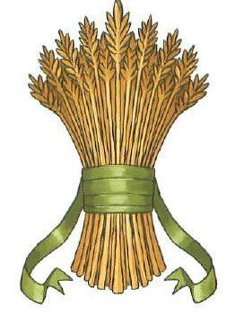

&

10th Oct – Special Guest

Welcome to guest speaker Christel Langdon-Griffiths

(Christian Aid), as we kick off our

Prayer Boat campaign for COP26



24th Oct -Bible Sunday

We welcome guest speaker Osoba Otaigbe

of the Bible Society

Warrington

Waterstones ‘Pop Up’ Book Shop



&

31st Oct -All Souls Day

A Special Service remembering

those we love, who have died

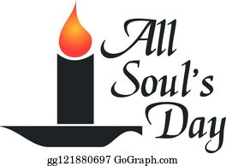

Wed lunchtimes in Nov - 12-1pm

Following the Footsteps of Jesus

A read through and discussion about the

Gospel of Mark (in the church café)

together with our friends from Kings Church



Sunday 14th Nov - Remembrance Sunday

A Service to honour the war dead and all

victims of conflict

Tues 3oth Nov – 9am-3pm

-St Andrew’s Community Day

An Open Day to celebrate our Patronal Festival. A free programme of music, events, refreshments, and a nostalgic exhibition of Orford through the years.

In association with Warrington Library & Museum Services.

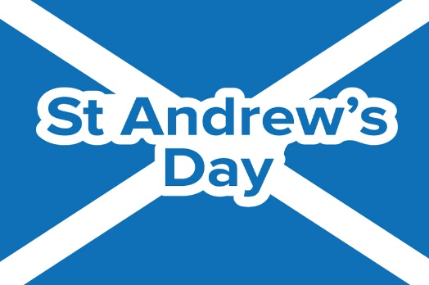

Wednesdays in Dec – 6.30pm

Exploring the Poetry of Advent

4 Evenings of poetry & creative writing

exploring the themes of the season,

with our friends from St Stephen’s

**Meet in St Andrew’s Church Hall.**

